Pengujian 1



Posisi Send-Recv

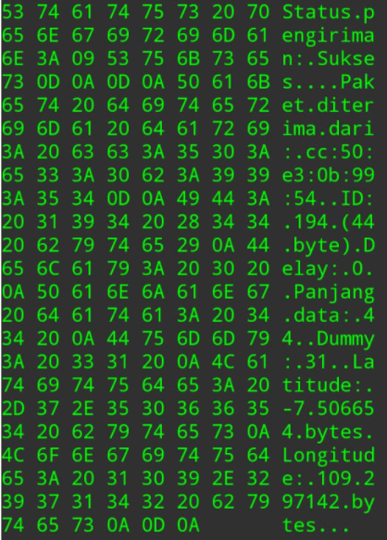

Data yang diterima.

Posisi RecvSend -7.506654,109.297142

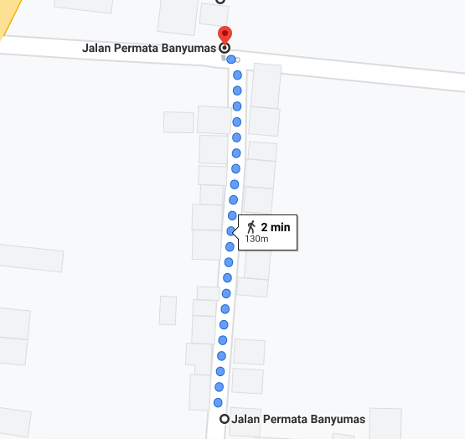

Perhitungan Jarak

Pengujian 2

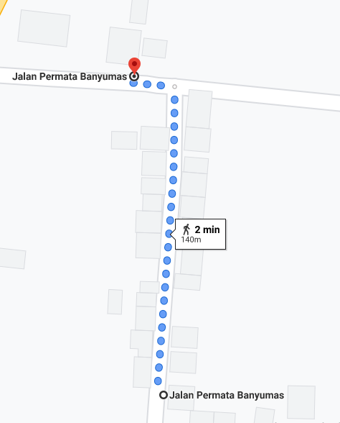

Pengujian Jarak

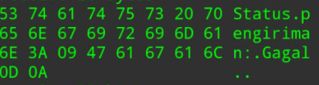

Data yang diterima.

Pengujian 44 Byte

|  |  |  |  |
| --- | --- | --- | --- |
| NO | Jarak (m) | Delay Mak(mS) | Success Rate(%) |
| 1 | 0 | 1 | 100 |
| 2 | 10 | 1 | 100 |
| 3 | 20 | 1 | 100 |
| 4 | 30 | 1 | 100 |
| 5 | 40 | 1 | 100 |
| 6 | 50 | 1 | 100 |
| 7 | 60 | 1 | 98 |
| 8 | 70 | 2 | 94 |
| 9 | 80 | 2 | 94 |
| 10 | 90 | 2 | 92 |
| 11 | 100 | 4 | 92 |
| 12 | 110 | 4 | 92 |
| 13 | 120 | - | 0 |

|  |  |  |  |  |
| --- | --- | --- | --- | --- |
|  |  |  |  |  |

|  |  |  |  |
| --- | --- | --- | --- |
| NO | Jarak (m) | Delay Mak(mS) | Success Rate(%) |
| 1 | 0 | 1 | 100 |
| 2 | 10 | 1 | 100 |
| 3 | 20 | 1 | 100 |
| 4 | 30 | 1 | 100 |
| 5 | 40 | 1 | 100 |
| 6 | 50 | 1 | 100 |
| 7 | 60 | 1 | 98 |
| 8 | 70 | 2 | 94 |
| 9 | 80 | 2 | 94 |
| 10 | 90 | 2 | 92 |
| 11 | 100 | 4 | 92 |
| 12 | 110 | 4 | 92 |
| 13 | 120 | - | 0 |
|  |  |  |  |

Pembacaan data melalui Serial Monitor Arduino

